**1. Axes of evil**

Let's take a look at problems with axes in plots.

**2. Nonsense bar lengths**

One thing that is fundamental to bar plots is that the length of each bar is proportional to whatever value it represents. In this infographic found on the wonderful subreddit, "dataisugly", the 22-point-5 percent scored by Yang in the poll appears to be much larger than the 21 percent scored by Sanders, or "Bernie", as he is affectionately referred to here. If we draw the bar plot correctly, you can see that the difference between the two poll scores is fairly small. I don't want to single out Yang specifically, but I would like to warn you to be cautious when interpreting plots on political posters.

1. 1 https://www.reddit.com/r/dataisugly/comments/exewcc/thats_quite_a_large_15

**3. The same applies to stacked bar plots**

It isn't just politicians who play fast and loose with the rules of data visualization. This time we have a stacked bar plot from dataisugly, about market share of phone operating systems. The problem with this is more subtle. Rather than making up bar lengths to look good on a poster, the values do match a real scale. The mistake is that the y-axis, containing market share, begins at seventy-five percent instead of zero. This makes it look like Android and iOS have similar market shares. If we draw the stacked bar plot correctly, we see that Android has a much larger share.

1. 1 https://www.reddit.com/r/dataisugly/comments/d76ixt/lets_make_13_vs_87_market_share_look_like_5050

**4. Dual axes are misleading**

Another common bad idea for plots is to use two y-axes. This is typically done when you want to plot two things on the y-axis with very different scales. Here you can see the United Nations dataset, with length of schooling on the x-axis. The red points are related to life expectancy and link to the y-axis on the left. The blue points link to the human development index for the country and link to the y-axis on the right. The two axes are needed here because the life expectancies are all between fifty and ninety, but the human development index is on a scale from zero to one. The problem is that by changing the right-hand y-axis, the interpretation of the plot completely changes. On the left, it looks there is a strong correlation between life expectancy and human development index, but on the right it looks like there is no correlation. You have to stare hard at the numbers on the axis to see what is going on.

**5. Better to use multiple panels**

A much better solution is to admit that you are trying to plot two different things, and keep them in separate panels, so it's clear to your audience that they are different metrics.

**6. Let's practice!**

Time to play with some axes.

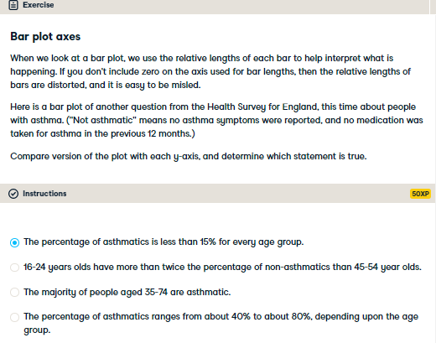

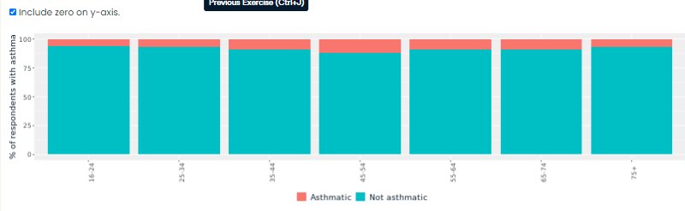

Bad-ass bar plot axis interpretation! When zero is not included in the y-axis, you have to really stare at the axis labels to know what is happening, and it is easy to be misled.

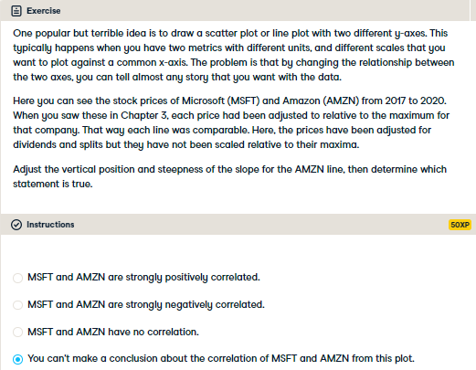

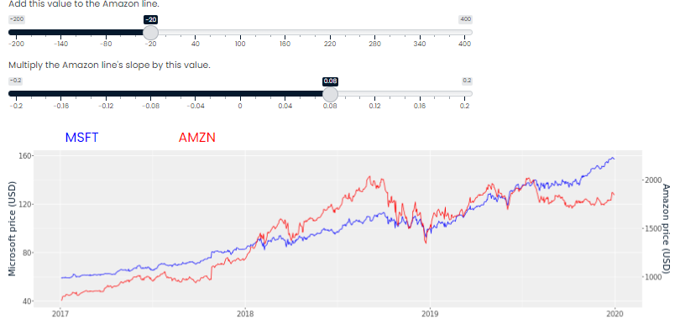

Delightful debunking of dual axes! It would have been better to draw each line in its own panel, like this.

